**Maharashtra**

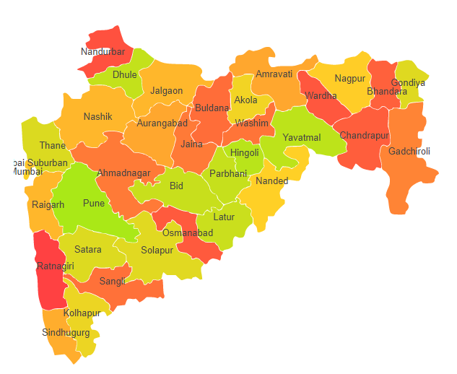

**Agro-Eco Region 5:** AER 5 in Maharashtra comprises of one Nandurbar district of Central (Malwa) Highlands under Agro Ecological Sub Region (AESR) 5.2.

**Agro-Eco Region 6:** AER 6 in Maharashtra comprises of Ahmadnagar, Akola, Amaravati, Aurangabad, Bid, Buldhana, Dhule, Hingoli, Jalgaon, Jalna, Kolhapur, Latur, Osmanabad, Parbhani, Pune, Sangli, Satara, Solapur, Nanded, Nandurbar, Nasik, Washim and Yavatmal districts of Deccan Plateau under Agro Ecological Sub Regions (AESR) 6.1, 6.2, 6.3 & 6.4.

**Agro-Eco Region 10:** AER 10 in Maharashtra comprises of Amaravati, Bhandara, Gondiya, Nagpur and Wardha districts of Central Highlands under Agro Ecological Sub Regions (AESR) 10.2 & 10.4.

**Agro-Eco Region 12:** AER 12 in Maharashtra comprises of Chandrapur and Gadchiroli districts of Eastern (Chhotanagpnr) Plateau under Agro Ecological Sub Region (AESR) 12.1.

**Agro-Eco Region 19:** AER 19 in Maharashtra comprises of Kolhapur, Raigarh, Ratnagiri, Sindhudurg, Suburban Mumbai, Thane and Mumbai City districts Thane of Western Ghats & Coastal Plain under Agro Ecological Sub Regions (AESR) 19.1,19.2 & 19.3.